

ADDRESS CHANGE AUTHORIZATION FORM
For:
RBC Dominion Securities Inc. & RBC Wealth Management Financial Services Inc.

Date:

Please change your records to reflect our new contact information and direct all future correspondence to the new address found above.
Thank you for your help.

RBC DS ACCOUNTS:

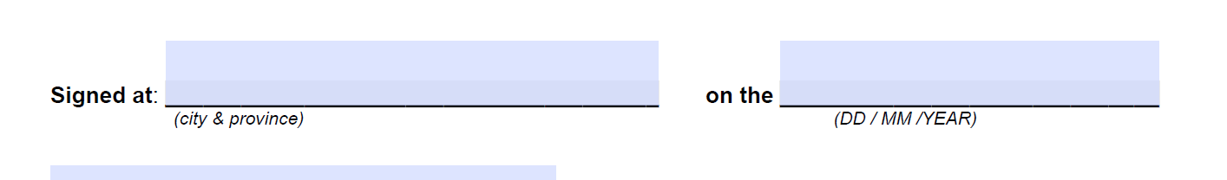

In signing below, I confirm that I am authorized to change the address on the investment accounts and insurance products indicated above, and consent to RBC DS and/or RBC WMFS, as applicable, updating their systems and records to reflect the new address and/or telephone number above, as well as providing the new address/telephone number information to the above-mentioned insurance company(ies) so that they may update their systems and records accordingly. In addition, I consent to RBC DS and/or RBC WMFS retaining a copy of this letter of authorization and the information contained therein, which will be used solely for the purpose of updating my address/telephone number information. Please refer to the RBC Global Privacy Notice for more information about our privacy practices.

