In our seventh annual letter to our clients, we will share some of the highs and lows of the past year and, as always, your feedback is welcome.

Equities and fixed income finished in positive territory

Annual letter to clients 2023
Michael Kirkpatrick
From January 1 to December 20, 2023, the Canadian stock market (S&P/TSX Composite Index) was up 7.5%. The world stock market (MSCI World Index) was up 21.2% over the same time period.
What would we have done differently?
If we could go back to January 1, we would have allocated more money to U.S. equities or international equities. U.S. equities (the S&P 500) were up 26.2% while international equities (MSCI EAFE) were up 13.1%.
Market highlights and lowlights
In 2022, the Canadian stock market (S&PTSX) was down 9%, and there was much concern about the economy stalling and stocks having another bad year. Despite that backdrop, and despite big pullbacks during the year, somehow, the stock market finished in positive territory. Not only that, despite interest rates going up, most fixed income assets also finished in positive territory: the Canadian Universe Bond Index ETF (ticker XBB) was up 6.47%. That is not bad for bonds, but it is on the heels of a bad year in 2022.
One item I will point out is that, even when the stock market finishes the year in positive territory, it can experience bad stretches during the year.
The chart below shows the average intra-year pull back of the stock market, and we can see on average it will go down 16% even in years when it finished in positive territory. This year was no different as we saw the TSX drop 9% from September 15 to October 27, 2023

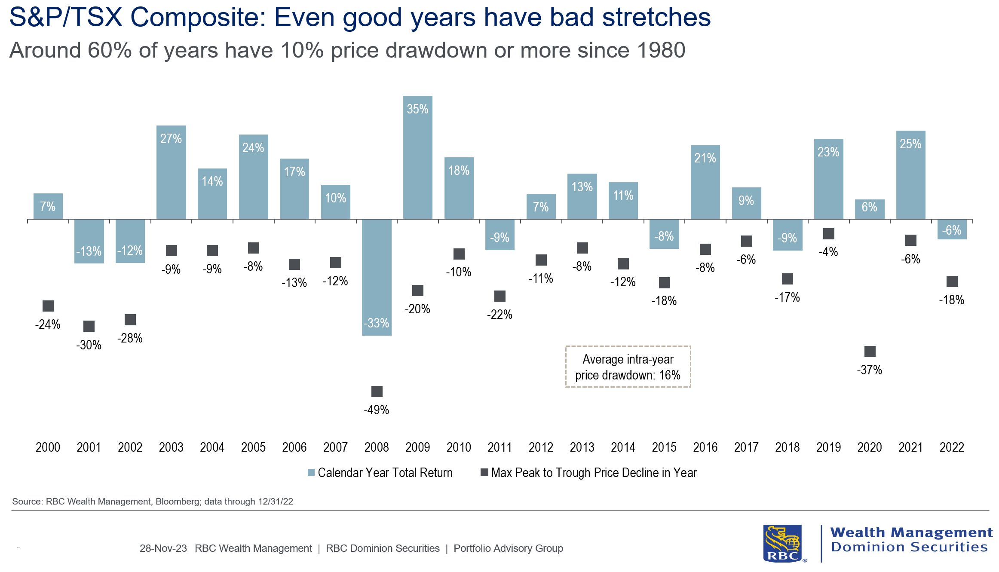
The chart below shows that it is rare for the stock market to have back-to-back down years so that is nice to know, and was pertinent to us, as 2022 was a down year for the stock market:
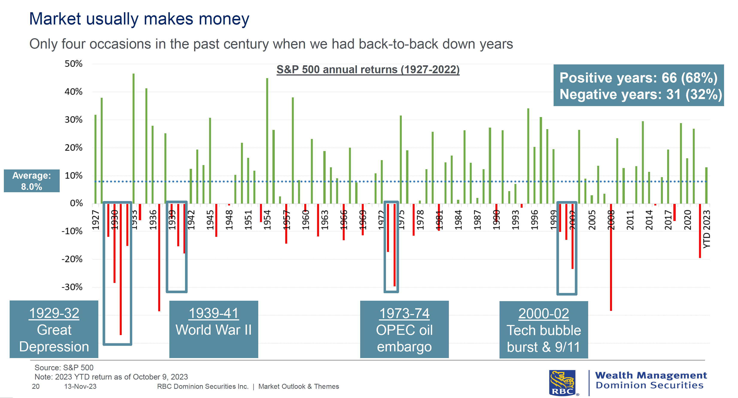

Wealth management highlights and updates
Estate planning: Leave a legacy…not a burden!
We all know we’re not going to live forever. As a result, our loved ones would very much appreciate if we planned for the time when we graduate from this earth. If your estate plan is planned well, and has been communicated to everyone, it will make life much easier for your executor, Power of Attorney (POA) and loved ones. As you know, we have many articles, and guidebooks and videos to help you with the estate planning process. We also have Estate Planning Consultants and Will and Estate Advisors to help you discuss your estate planning objectives.
If you have elderly parents, please make sure they have undertaken the estate planning mentioned above, and encourage them to consolidate their assets with one institution, as this will make the executor’s life much easier when they have to step into that role.
Elder-care planning
Financial abuse of seniors is one of the darker realities of aging, and one that tends to stay out of the view of those not directly touched by it. It’s a crime that’s often not seen by the victim, and sadly often perpetrated by family members or close acquaintances. This article shares how to recognize and prevent financial elder abuse.
Be cyber-aware
We safeguard our health. We safeguard our investments. It is critical that we all become more cyber-aware and safeguard our online activities. This article shares How to Protect your Family from Cyber Scams.
Auto-funding TFSAs
We can now fund your Tax Free Savings Accounts (TFSAs) automatically using cash from your bank account or non-RSP account. This ensures that your TFSA is fully funded on January 1st of each year. Just reach out if you would like to have this set up. The 2024 TFSA dollar limit is $7,000.
First Home Savings Account (FHSA)
The FHSA is a new registered account to help individuals save up to $40,000 on a tax-free basis to purchase their first home. Here are more details on the FHSA and click here to view my thoughts on the FHSA.

The Smith Manoeuvre
The Smith Manoeuvre is a debt conversion strategy where a homeowner converts their non-deductible mortgage debt into tax-deductible debt over time. The benefits include:
- Paying off the mortgage sooner
- Creating a new growing stream of tax deductions
- Building a non-RSP portfolio
No new cash flow, above and beyond the monthly mortgage payment, is required to accomplish the above items. I have shared the story with all of you, and will continue to do so as I think all Canadian homeowners who have a mortgage need to know about it. Here is a helpful webinar that clearly explains the concept.
You finance everything you buy. You either earn interest, or you pay interest
When making major capital purchases, it is a good idea to consider the best way to finance the purchase. The following simple example helps us appreciate a few items.
If $50,000 were invested at 5% over the next five years, it would earn $14,168 in interest, and the final balance will be $64,168.
Meanwhile, $50,000 borrowed at 10% with monthly payments of $1,062 would cost $13,741 in interest over the five-year time period.
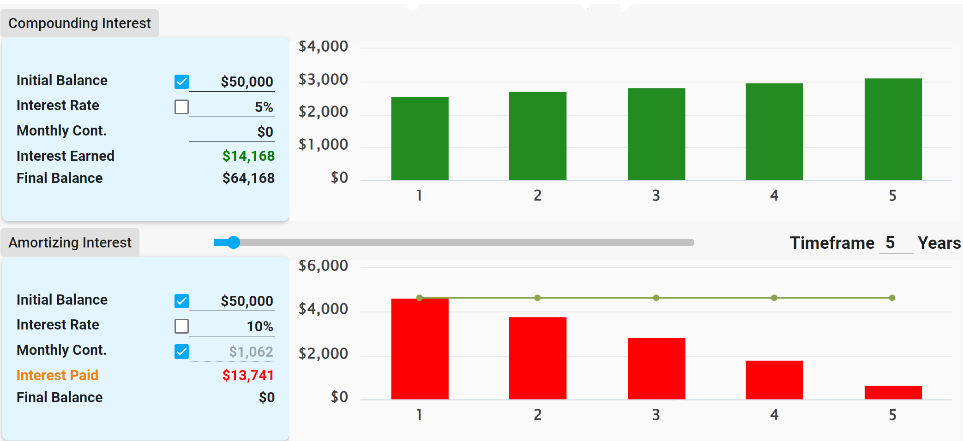
We are ignoring taxes and the return on the monthly payments had that amount been invested, but the example does make one consider the benefits of retaining control of one’s capital. Keeping your capital provides you with liquidity, use, and control of your money in case an emergency or opportunity pops up. The above example also helps us appreciate the power of uninterrupted compounding as we can see that despite growing at a lower rate (5%) the interest earned ($14,168) over the five years is slightly higher than the interest paid on the 10% loan ($13,741).
Infinite Banking Concept (IBC)
I have created videos to help share the IBC story, which you can view by clicking here. As mentioned above, 2023 was a good year for stocks, but 2022 was a bad year for just about every asset class. Despite the challenges in 2022, the cash values on participating whole life insurance policies continued to go up. Over the past year, just about every insurance company’s participating fund has increased their dividends to policyholders, which means that cash values and death benefits will be higher than expected.
Wealth Management (WM) Online
Our WM Online portal allows you to view your accounts, update your address or contact details, and pull up account statements and tax documents when it’s most convenient for you. When you are logged in to your portal, you can communicate with us using your secure inbox. This is the most secure way for us to communicate and send documents back and forth. I encourage you to get comfortable using it, and we are happy to help you get set up as well. Note that you can log in via the desktop website or via the RBC Mobile app on your phone or handheld device.
2023 Taxes
Your 2023 tax documents can be accessed online, so if you would prefer to receive your tax documents electronically instead of by mail, please let us know, or you can make the switch via WM Online (click on “Settings,” then the “Document Delivery” tab and then click on the “delivery type” drop down menu to make the change, followed by “save changes”).
Here is the link to our 2023 Tax Reporting Guide.
Education and business operations

Congratulations to Allison Book, our Associate, on completing the Canadian Securities Course and the the Conduct and Practices Course. Her goal in 2024 is to begin the Wealth Management Essentials course.

I completed two accounting courses at Carleton University – Business Combinations and Auditing. I still have four more courses to finish in order obtain my post baccalaureate diploma in accounting.

The more I learn, the more I can help add value and make a difference to you and your family.

Books

The last two years, I have been recommending the book Become Your Own Banker (BYOB) by the late Nelson Nash. I will continue to try and find books that I think are relevant to you, and will share them when I find a good one. Your book recommendations are also welcome.

Portfolio highlights and lowlights

On the fixed side of the portfolio, our worst performers were:
- ZRR BMO Real Return Bond Index ETF, which was down 4.61%; and
- CVD iShares Convertible Bond Index ETF, which was down 4.39%.

Our best performers on the fixed side were:
- VBG Vanguard Global (ex-US) Aggregate Bond Index ETF, which was up 6.12%; and
- Renaissance Floating Rate Income Fund, which was up 5.16%.

I wrote a piece called, “When interest rates go up, bond prices go down…until they mature.” Now that interest rates have moved up, I think the future looks friendly for our fixed income holdings. Feel free to read more about this in our 2024 Outlook, which states: “Bonds are back!”

I have never seen a time when our fixed income holdings were averaging a yield of over 4%, so I look forward to seeing how fixed income can start to contribute more to our overall returns.

On the equity side, our worst performers were:
- ZRE BMO Equal Weight REIT ETF, which was down 6.02%;and
- BMG Bullion, which was down 0.61%.

Our best performers on the equity side were:
- VSP Vanguard S&P500 Index ETF (CAD hedged), which was up 23.09%; and
- XIN iShares MSCI EAFE Index ETF (CAD hedged), which was up 16.6%.

Heading into 2024, I am looking at the dividends from some of the big Canadian companies that we own:
- Royal Bank 4.11%
- TC Energy 7%
- BCE 7.53%

My thought is that, if we just collected those dividends and ignored the capital growth, I would be pleased with returns like that. That said, many of these companies increase their dividends each year and, over the long term, their stock price usually ends up being higher. I wrote an article called “Owner vs Loaner” and, on the second page, you can see the growth rate of the RBC dividend over a 10-year period. Note that, with a mix of equities and fixed income, we are both owners and loaners, which means we benefit from the features each asset provides us with.

Going forward

As the below chart indicates, continuing to own good companies over the long run will result in higher returns, whereas trying to time the market can get investors into trouble. We can see the impact that missing the best days (i.e. days of high stock market returns) can have on a portfolio. This is why I will never call you to say we are selling everything and will buy back later. It is impossible to do this successfully and consistently.
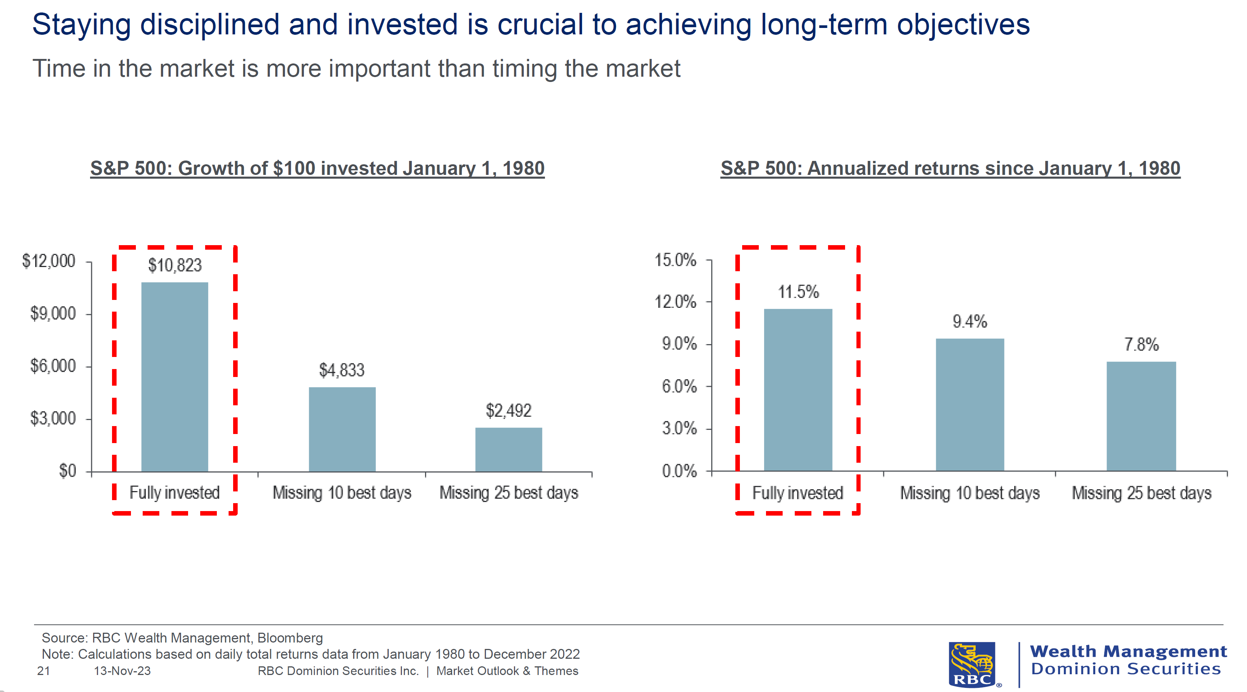
The chart below helps us appreciate that, over the long term, the probability of experiencing negative returns gets reduced over time, and that the range of returns also reduces over time. Again, this supports the idea of staying invested over the long term.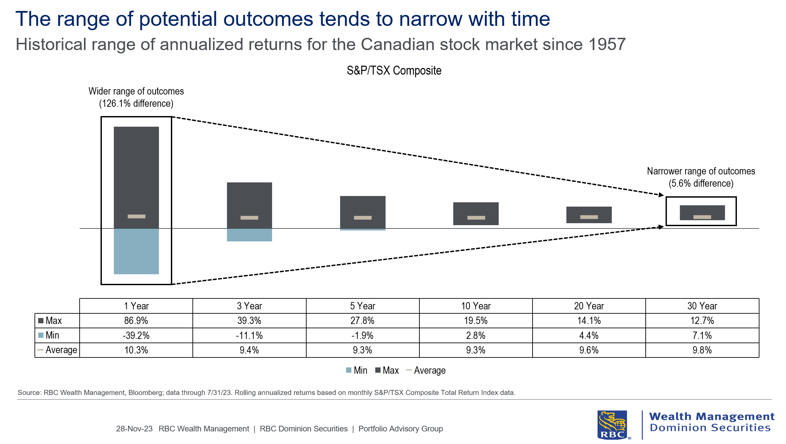

I am happy with our ETF models, and I will continue to make sure each of you have the right balance between equity and fixed income. As always, dollar-cost averaging, or regular contributions, is the best way to deploy new money or cash as it removes the guesswork, acknowledges that we cannot time the market in the short term, but also that, over the long term, equity prices will rise.
Thank you

Allison and I want to thank you for your trust, and we look forward to serving you in 2024 and beyond.
Here’s to the end of 2023 and to the start of a New Year!
Michael Kirkpatrick

