 | RBC Dominion Securities Inc.  Jan November 2019


November 2019 Newsletter

Hope your November is going well. As we head towards the end of the year, it is natural to look back, and also contemplate the future. The markets have generally been up this year. We can be grateful for that. At the same time, a lot of people are concerned about an upcoming market downturn. There will be a downturn at some point. There always is. However, I don’t know when it will start, how deep it will go, and for how long it will last. For some, the potential of a downturn, causes some daily concern. This is a great article about how to look at a potential, future downturn:
Living in Fear of a Market Downturn

As year-end approaches, here’s a summary of some common year-end tax planning strategies. If there is anything that you wish to have accomplished in your accounts or planning by year-end, of course, call us.
Of course, if you have any questions about how this applies to you or someone you care about, feel free to call or reply to this email.
Have a happy November, Charles

1. U.S. Corner
Why ‘Accidental Americans’ Have An Uphill Battle with the IRS

2. Other Items of Interest
The Corporate Implications of Longer Lives
What Makes Some People More Productive Than Others

3. Where markets are going next
It’s the time of the year when we will start to get some forecasts on where the market is going. How accurate are these? Not very. Below is an article for a few years back, but I don’t think much would have changed since then.
How Accurate Are Those Annual Market Forecasts?

4. Evidence-Based Investment Insights
In our last piece, “Managing the Market’s Risky Business,” we described how diversification plays a key role in minimizing unnecessary risks and helping you better manage those that remain. Today, we’ll cover an additional benefit to be gained from a well-diversified stable of investments: creating a smoother ride toward your goals.
Diversifying for a Smoother Ride
Like a bucking bronco, near-term market returns are characterized more by periods of wild volatility than by a steady-as-she-goes trot. Diversification helps you tame the beast, because, as any rider knows, it doesn’t matter how high you can jump, if you fall out of the saddle. High or low, you’re going to get left in the dust.
When you crunch the numbers, diversification is shown to help minimize the leaps and dives you must endure along the way to your expected returns. Imagine several rough-and-tumble, upwardly mobile lines that represent several kinds of holdings. Individually, each represents a bumpy ride. Bundled together, the upward mobility by and large remains, but the jaggedness along the way can be dampened (albeit never completely eliminated).
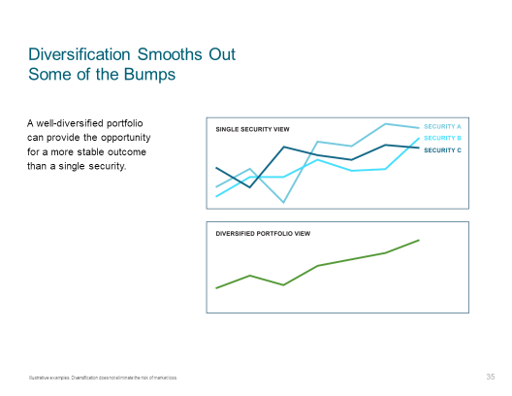
If you’d like to see data-driven illustrations of how this works, check out “How to diversify your investments,” by financial author Larry Swedroe, or “When boring is good investing,” by financial author Craig L. Israelsen.
Covering the Market
A key reason diversification works is related to how different market components respond to price-changing events. When one type of investment may zig due to particular news, another may zag. Instead of trying to move in and out of favored components, the goal is to remain diversified across a wide variety of them. This increases the odds that, when some of your holdings are underperforming, others will outperform or at least hold their own.
The results of diversification aren’t perfectly predictable. But positioning yourself with a blanket of coverage for capturing market returns where and when they occur goes a long way toward replacing guesswork with a coherent, cost-effective strategy for managing desired outcomes.
The Crazy Quilt Chart is a classic illustration of this concept. After viewing a color-coded layout of which market factors have been the winners and losers in past years, it’s clear that the only discernible pattern is that there is none. If you can predict how each column of best and worst performers will stack up in years to come, your psychic powers are greater than ours.
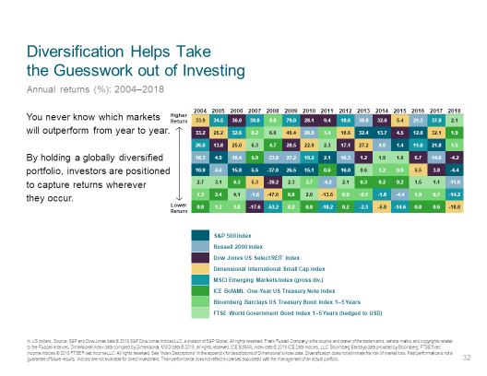

Your Take-Home
Diversification offers you wide, more manageable exposure to the market’s long-term expected returns as well as a smoother expected ride along the way. Perhaps most important, it eliminates the need to try to forecast future market movements, which helps to reduce those nagging self-doubts that throw so many investors off-course.
So far in our series of Evidence-Based Investment Insights, we’ve introduced some of the challenges investors face in efficient markets and how to overcome many of them with a structured, well-diversified portfolio. Next up, we’ll pop open the hood and begin to take a closer look at some of the mechanics of solid portfolio construction.
Charles W. Cullen III, BSE (Hons), CFP® (Canada & U.S.), CIM® | Vice-President, Portfolio Manager and Wealth Advisor, Cullen Wealth Management | RBC Wealth Management | RBC Dominion Securities, Inc.
T. 902-424-1092 | TF. 866-922-6111 | C. 902-789-3838 | F. 902-425-0608
1959 Upper Water St, Suite 1400, Purdy's Wharf Tower 1, Halifax, NS B3J 3N2
http://www.cwcullen.com | charles.cullen@rbc.com
Shelagh Tracey | Associate | T. 902-421-0244 | shelagh.tracey@rbc.com
Jonathan MacLanders, CFA | Associate Investment and Wealth Advisor | T. 902-494-5694 | jonathan.maclanders@rbc.com
Privacy & Security | Legal | Accessibility | Member-Canadian Investor Protection Fund

RBC Dominion Securities Inc.* and Royal Bank of Canada are separate corporate entities which are affiliated. *Member-Canadian Investor Protection Fund. RBC Dominion Securities Inc. is a member company of RBC Wealth Management, a business segment of Royal Bank of Canada. ®Registered trademarks of Royal Bank of Canada. Used under licence. © RBC Dominion Securities Inc. 2016. All rights reserved.

This information is not intended to solicit non-residents of Canada. This information is not intended as nor does it constitute tax or legal advice. Readers should consult their own lawyer, accountant or other professional advisor when planning to implement a strategy. This information is not investment advice and should be used only in conjunction with a discussion with your RBC Dominion Securities Inc. Investment Advisor. This will ensure that your own circumstances have been considered properly and that action is taken on the latest available information. The information contained herein has been obtained from sources believed to be reliable at the time obtained but neither RBC Dominion Securities Inc. nor its employees, agents, or information suppliers can guarantee its accuracy or completeness. This report is not and under no circumstances is to be construed as an offer to sell or the solicitation of an offer to buy any securities. This report is furnished on the basis and understanding that neither RBC Dominion Securities Inc. nor its employees, agents, or information suppliers is to be under any responsibility or liability whatsoever in respect thereof. The inventories of RBC Dominion Securities Inc. may from time to time include securities mentioned herein. RBC Dominion Securities Inc.* and Royal Bank of Canada are separate corporate entities which are affiliated. *Member-Canadian Investor Protection Fund.
To unsubscribe, please click here.

