RBC Dominion Securities Inc.
Jan February 2019

February 2019 Newsletter

“Investors that want to earn the long-term returns of the capital markets should appreciate that market declines are a part of investing and one of the reasons that stocks have historically had a higher return than other investments.”
What a difference a month makes…. On Christmas Eve, markets were in a free fall and in January, they have generally been going up. Of course, we can’t predict where the market will head in the next month, but historically stocks have had higher returns than other investments. I’ve included a note below about RRSP and TFSA contributions, which may or may not be applicable in your situation. We’ve also included a few links regarding the passing of Jack Bogle, founder of the Vanguard Group. He has had a major impact on the investment industry over the past couple of generations. On a more personal level, in university, one of his books was required reading in my Corporate Finance class.
Of course, if you have any questions, please reply to this email or call me at 902-424-1092.
Charles

1. TFSA / RRSP Contributions
You can now make your Tax-Free Savings Account (TFSA) contribution for 2019 (up to $6,000). If you haven’t opened your TFSA yet, you may have contribution room of $63,500.
A TFSA can also be a great way for you to reduce your family’s overall tax bill. Your spouse and any adult children who have reached the age of majority (in the province/territory where they live) can each contribute up to $6,000 to their own TFSAs in 2019, even if they don’t have any earned income.
The RRSP contribution deadline for the 2018 tax year is March 1, 2019. Your contribution limit for 2018 is 18% of your 2017 earned income, to a maximum of $26,230, with certain adjustments (e.g. less any Pension Adjustment appearing on your 2017 T4 tax slip and plus any unused contribution room carried forward from previous years).
For your exact contribution limit, check your latest Notice of Assessment, Notice of Reassessment or T1028 form, or log on to your Canada Revenue Agency account at http://www.cra-arc.gc.ca/myaccount.
You can also make your 2019 contribution any time starting January 1, 2019 to benefit from additional tax-deferred compounding. The maximum RRSP contribution room you can earn for 2019 is $26,500.
Please email us at Cullen.wealth@rbc.com to arrange your 2018/2019 RRSP contributions. You can also make a contribution by transferring funds to your RBC Dominion Securities RRSP account directly from any RBC Royal Bank account through DS Online. For DS Online help or more information on transferring funds, contact Shelagh Tracey at 902-421-0244 or Cullen.wealth@rbc.com .

2. U.S. Corner
Voting Restrictions on Expatriate Citizens are Unconstitutional, Supreme Court Rules
U.S. sues Vancouver dual citizen for over $1M for not reporting accounts
1.6 Million Canadian Banking Records Shared with IRS
IRS Says Hundreds of Thousands of US Citizens Are Not Reporting Canadian Trusts

3. Thoughts on Investing & Planning
Jack Bogle Changed Your Life Even If You Don’t Know Who He Was
The Things Jack Bogle Taught Us: Humility, Ethics, and Simplicity
Whether You’re a Stock or Bond may Determine When to Take CPP/OAS

4. Interesting Videos
David Booth on Market Forecasting
Recent Market Volatility

5. A Question of Equilibrium
"Sellers were out in force on the market today after negative news on the economy." It's a common line in TV finance reports. But have you ever wondered who is buying if so many people are selling?
The notion that sellers can outnumber buyers on down days doesn’t make sense. What the newscasters should say, of course, is that prices adjusted lower because would-be buyers weren’t prepared to pay the former price.
What happens in such a case is either the would-be sellers sit on their shares or prices quickly adjust to the point where supply and demand come into balance and transactions occur at a price that both buyers and sellers find mutually beneficial. Economists refer to this as equilibrium.
But the price at which equilibrium is reached can change. That’s because new information is coming into the marketplace continually, forcing would-be sellers and would-be buyers to constantly adjust their expectations.
That new information might be company-specific news on earnings. It might be news that has implications for specific industries—like a spike in oil prices. Or it might be an economic development that affects the entire market, like a change in the unemployment rate. Given this constant flux in the flow of news and information and the changing expectations of participants, it can be reassuring to remember that for everyone selling shares there must also be buyers of those shares—or the trade will never take place. And whenever information changes, prices may change and quickly reach a new level of equilibrium.
Recent trading activity by market participants in shares of a US-based health care provider offers a clear example of how quickly prices adjust to new information. It was reported in late July 2018 that a large private equity firm was in talks to purchase the health care firm at a price valuing the company at $65 per share. Prior to the announcement, shares of the firm were trading around $48. As we see in Exhibit 1, when the announcement broke, the market price for the stock adjusted overnight to just below $65. In other words, after news of the impending sale hit the market, the supply and demand for the stock met at a new equilibrium price.
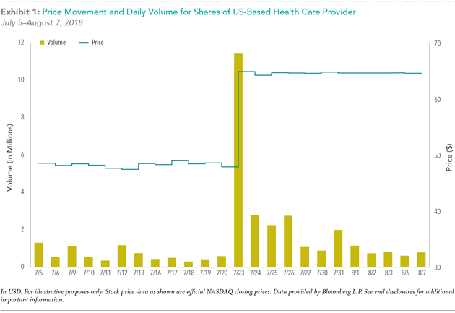
Given that security prices rise and fall based on a multiplicity of influences, how should investors interpret and act on these signals? We believe that trying to untangle all these influences and profit from perceived mispricing is not possible in a systematic and scalable manner.
An alternative approach is to start by accepting that prices are fair and reflect the collective expectations of market participants. While information frequently changes, this is quickly built into prices. Competition among buyers and sellers is such that it’s not possible to consistently outguess the market.
The second step is to see that fairly priced securities can have different expected returns. And we can use market prices and security characteristics to identify those securities that offer higher expected returns.
The third step is to build highly diversified portfolios around these broad drivers of return, while implementing efficiently and managing the cost of buying and selling securities.
The final step is to apply discipline and rebalance your portfolio to either stay within your chosen risk parameters or to adjust for changes in circumstances.
Ultimately, the market is like a giant information processing machine. All the influences mentioned above are constantly being assessed by millions of participants, and prices adjust based on those collective expectations.
The returns we expect from investing do not necessarily show up every day, every week, every month, or even every year. But the longer we stay invested, the more likely we are to capture them. So, rest assured that even when prices are falling, people are still buying. The market is doing its job, and we believe the rewards will be there if you remain disciplined.

Charles W. Cullen III, BSE (Hons), CFP® (Canada & U.S.), CIM® | Vice-President, Portfolio Manager and Wealth Advisor, Cullen Wealth Management | RBC Wealth Management | RBC Dominion Securities, Inc.
T. 902-424-1092 | TF. 866-922-6111 | C. 902-789-3838 | F. 902-425-0608
1959 Upper Water St, Suite 1400, Purdy's Wharf Tower 1, Halifax, NS B3J 3N2
http://www.cwcullen.com | charles.cullen@rbc.com
Shelagh Tracey | Associate | T. 902-421-0244 | shelagh.tracey@rbc.com
Jonathan MacLanders | Associate Advisor | T. 902-494-5694 | jonathan.maclanders@rbc.com
Privacy & Security | Legal | Accessibility | Member-Canadian Investor Protection Fund

RBC Dominion Securities Inc.* and Royal Bank of Canada are separate corporate entities which are affiliated. *Member-Canadian Investor Protection Fund. RBC Dominion Securities Inc. is a member company of RBC Wealth Management, a business segment of Royal Bank of Canada. ®Registered trademarks of Royal Bank of Canada. Used under licence. © RBC Dominion Securities Inc. 2016. All rights reserved.

This information is not intended to solicit non-residents of Canada. This information is not intended as nor does it constitute tax or legal advice. Readers should consult their own lawyer, accountant or other professional advisor when planning to implement a strategy. This information is not investment advice and should be used only in conjunction with a discussion with your RBC Dominion Securities Inc. Investment Advisor. This will ensure that your own circumstances have been considered properly and that action is taken on the latest available information. The information contained herein has been obtained from sources believed to be reliable at the time obtained but neither RBC Dominion Securities Inc. nor its employees, agents, or information suppliers can guarantee its accuracy or completeness. This report is not and under no circumstances is to be construed as an offer to sell or the solicitation of an offer to buy any securities. This report is furnished on the basis and understanding that neither RBC Dominion Securities Inc. nor its employees, agents, or information suppliers is to be under any responsibility or liability whatsoever in respect thereof. The inventories of RBC Dominion Securities Inc. may from time to time include securities mentioned herein. RBC Dominion Securities Inc.* and Royal Bank of Canada are separate corporate entities which are affiliated. *Member-Canadian Investor Protection Fund.
To unsubscribe, please click here.

